UI Rebranding Suggestions

Automate 360 Configurator
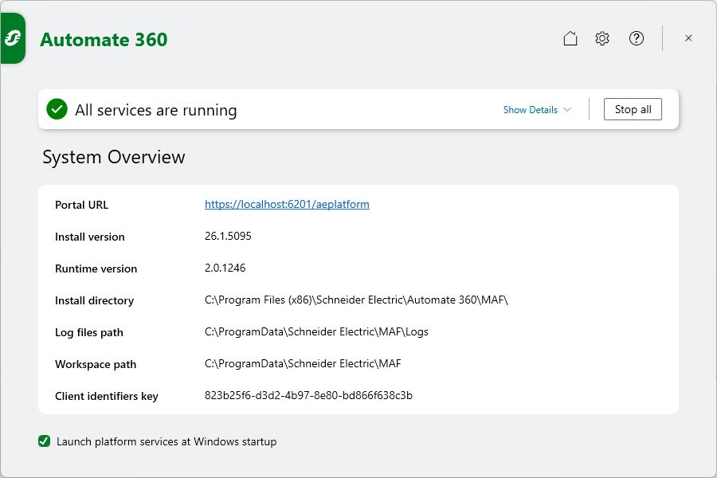

Messages in Service Status
Platform services starting
Change to Automate 360 services starting

Show Details
Change “Id” to “ID” in Service Id and Process Id.

System Overview Checkbox
Launch platform services at Windows startup
Change to Launch Automate 360 services at Windows startup

Certificate Tab
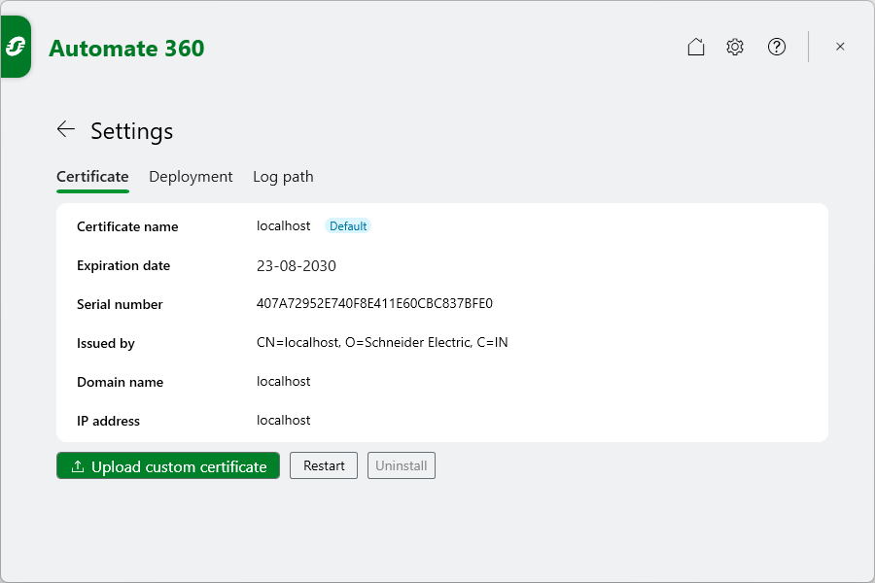
Change Uninstall to Uninstall certificate or Remove certificate to improve clarity.

Deployment Tab
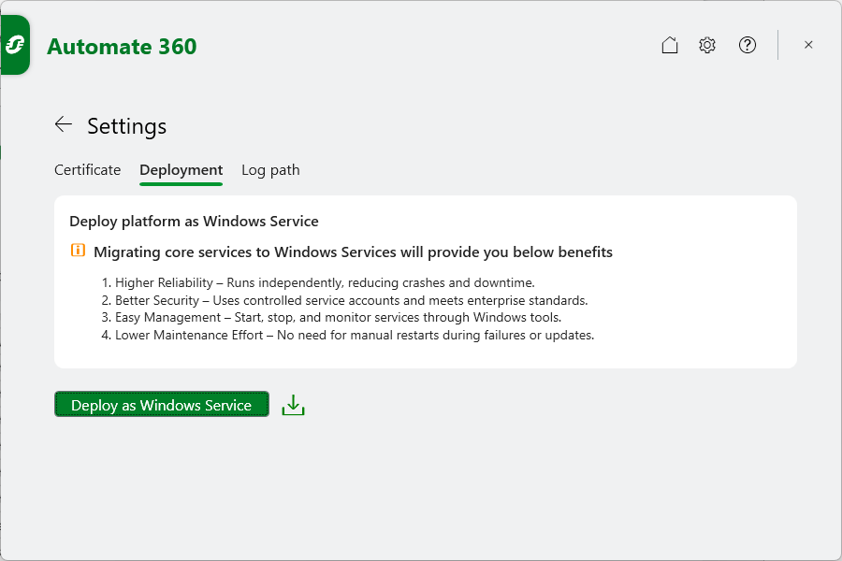
Existing: Deploy platform as Windows Service
Migrating core services to Windows Services will provide you below benefits
- Higher Reliability - Runs independently, reducing crashes and downtime
- Better Security - Uses controlled service accounts and meets enterprise standards.
- Easy Management - Start, stop, and monitor, services through Windows tool.
- Lower Maintenance Effort – No need for manual restarts during failures or updates.
Button: Deploy as Windows Service
Change:
- Deploy platform as Windows Service to Deploy Automate 360 as Windows Service
- Remove the download PDF icon.

Automate 360

Settings

Session Management
Platform Idle session timeout
Change to Automate 360 idle session timeout

